
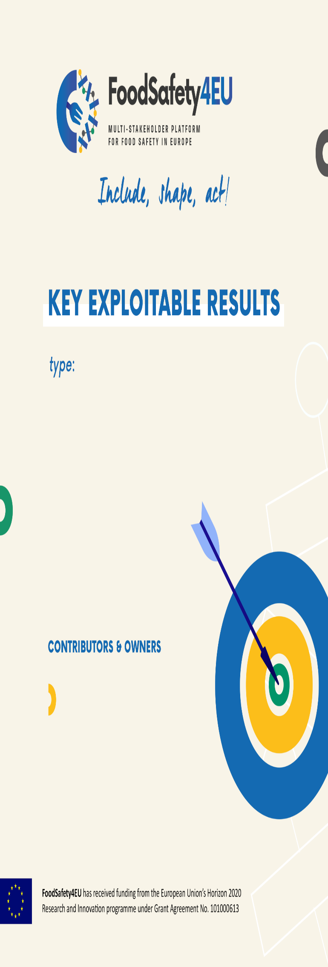

YOUNG SESSION:


“Youngs acti ng for the future of Foo d Safety Research & Innovation in EU”
💡 Pitch your idea in 60 seconds!
NAME: SURNAME:
ORGANIZATION/UNIVERSITY:

- WHO ARE YOU?
Describe your background and why you have chosen for a career in food safety

- WHAT IS YOUR FIELD?
Describe your research/business field and your role, team, organization you belong, topic/issue you are addressing.

- WHAT IS YOUR IDEA AND APPROACH AND/OR RESULTS?
Describe your idea, rationale and approach and most important results if you have them already.

- HOW DO YOU WANT TO HAVE AN IMPACT ON FOOD SAFETY?
Describe your ambition for the future and how your project will contribute to better food safety.

Submit your pitch by WeTransfer to:
Martina | martina.loi@cnr.it and David | david.steiner@lva.at

